Let's create examples that illustrate the three types of covariance (positive, negative, and zero covariance) and then plot the appropriate scatterplots to visualize them.
1. Positive Covariance:
- Example: Hours Studied vs. Exam Scores
- Data:
  - Student A: 2 hours, 60 marks
  - Student B: 4 hours, 65 marks
  - Student C: 6 hours, 70 marks
  - Student D: 8 hours, 75 marks
  - Student E: 10 hours, 80 marks
2. Negative Covariance:
- Example: Price of a Product vs. Quantity Demanded
- Data:
  - Price: $5, Quantity Demanded: 200 units
  - Price: $6, Quantity Demanded: 180 units
  - Price: $7, Quantity Demanded: 160 units
  - Price: $8, Quantity Demanded: 140 units
  - Price: $9, Quantity Demanded: 120 units
3. Zero (No) Covariance:
- Example: Temperature vs. Number of Ice Cream Scoops Sold in Winter
- Data:
  - Temperature: 30°F, Ice Cream Sales: 50 scoops
  - Temperature: 25°F, Ice Cream Sales: 52 scoops
  - Temperature: 20°F, Ice Cream Sales: 51 scoops
  - Temperature: 15°F, Ice Cream Sales: 50 scoops
  - Temperature: 10°F, Ice Cream Sales: 52 scoops
I'll now plot these datasets to visualize the covariance types.
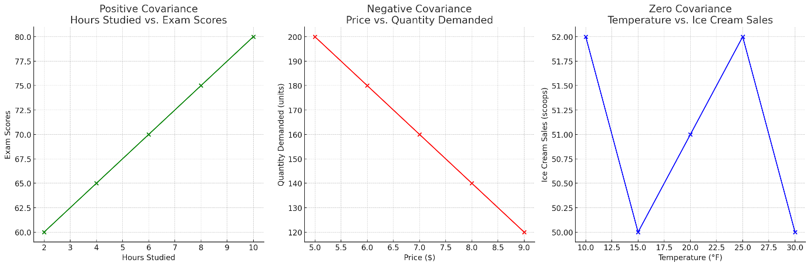
Here are the scatterplots for the three types of covariance:
- Positive Covariance: The plot of Hours Studied vs. Exam Scores shows that as the number of hours studied increases, exam scores also increase, indicating a positive relationship.
- Negative Covariance: The plot of Price vs. Quantity Demanded demonstrates that as the price increases, the quantity demanded decreases, showing a negative relationship.
- Zero (No) Covariance: The plot of Temperature vs. Ice Cream Sales in winter shows no clear relationship between the temperature and ice cream sales, indicating zero covariance. ​

Numerical
Example: Investigate relationship between cigarette smoking lung capacity
N | Cigarettes | Lung Capacity (Y )
1 | 0 | 45
2 | 5 | 42
3 | 10 | 33
4 | 15 | 31
5 | 20 | 29

Formula to calculate sample covariance
Similar to variance, for theoretical reasons, average is typically computed using (N-1) and not N
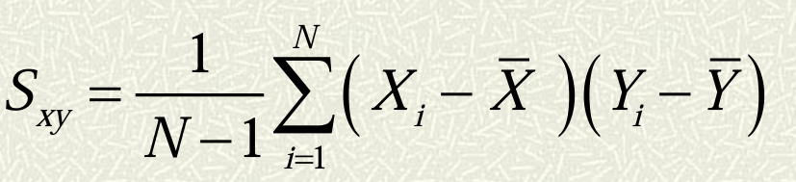
Step 1: Calculate mean for first and second attribute
N | Cigarettes | Lung Capacity (Y )
1 | 0 | 45
2 | 5 | 42
3 | 10 | 33
4 | 15 | 31
5 | 20 | 29
 | $\overline{x}$=10 | $\overline{y}$=36

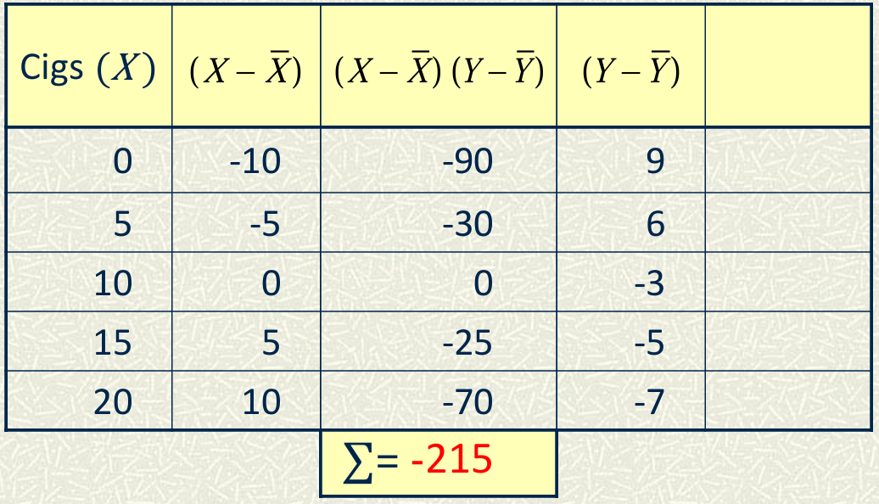

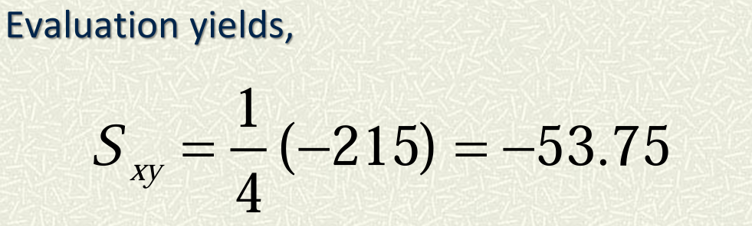

1. Perfect Positive Correlation
Example: Height and shadow length at a fixed time of day.
- Description: As height increases, shadow length also increases proportionally. The relationship is perfectly linear, with all data points lying on a straight line.
- Correlation Coefficient: r=1r = 1r=1
Chart:
- X-axis: Height (in cm)
- Y-axis: Shadow Length (in cm)
- Data Points:
  - (150, 150)
  - (160, 160)
  - (170, 170)
  - (180, 180)
2. High Positive Correlation
Example: Study hours and exam scores.
- Description: Generally, as study hours increase, exam scores tend to increase, though not perfectly. There is a strong positive relationship, but not all points lie on the straight line.
- Correlation Coefficient: r close to 1 (e.g., 0.8 or 0.9)
Chart:
- X-axis: Study Hours
- Y-axis: Exam Scores
- Data Points:
  - (1, 50)
  - (2, 60)
  - (3, 75)
  - (4, 85)
  - (5, 90)
3. Low Positive Correlation
Example: Age and job satisfaction.
- Description: As age increases, job satisfaction slightly increases, but the relationship is weak. The points are more scattered around a line that has a positive slope.
- Correlation Coefficient: rrr is positive but closer to 0 (e.g., 0.3 or 0.4)
Chart:
- X-axis: Age (in years)
- Y-axis: Job Satisfaction (scale 1-10)
- Data Points:
  - (25, 6)
  - (30, 6.5)
  - (35, 7)
  - (40, 7.2)
  - (45, 7.3)

Calculate the correlation coefficient for the following data:
X = 4, 8 ,12, 16
Y = 5, 10, 15, 20.
Step 1: Write down the data
- X= [4,8,12,16]
- Y= [5,10,15,20]
Step 2: Calculate the mean of X and Y
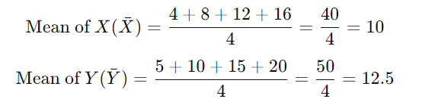
Step 3: Calculate the deviations from the mean for both X and Y
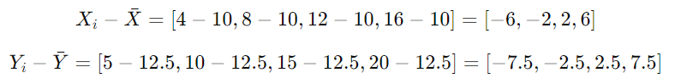
Step 4: Calculate the product of deviations for each pair
Step 5: Sum up the products of deviations
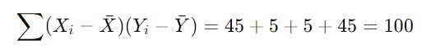
Step 6: Calculate the square of deviations for X and Y and sum them up
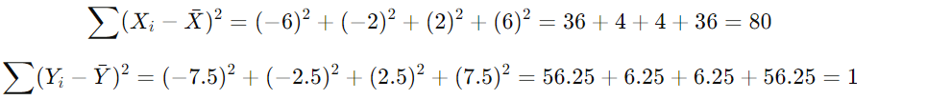

Step 7: Calculate the correlation coefficient r
The correlation coefficient formula is:
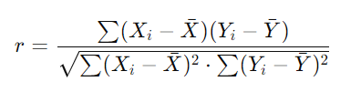
Substituting the values:
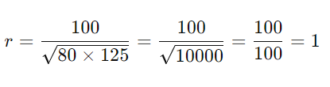
The correlation coefficient r=1, indicating a perfect positive linear relationship between X and Y.

Rep / Day | Qualified calls per rep (X) | Closed deals per rep (Y)
A | 4 | 5
B | 8 | 10
C | 12 | 15
D | 16 | 20

